**Module-3: Docker – I Assignment – 4**

**To Do :**

**Create a dockerfile with the following specs:**

● Ubuntu container

● Apache2 installed

● Apache2 should automatically run once the container starts

Submit the dockerfile, for assignment completion.

**Solution :**

sudo nano Dockerfile

**Added the following lines of code to the Dockerfile -**

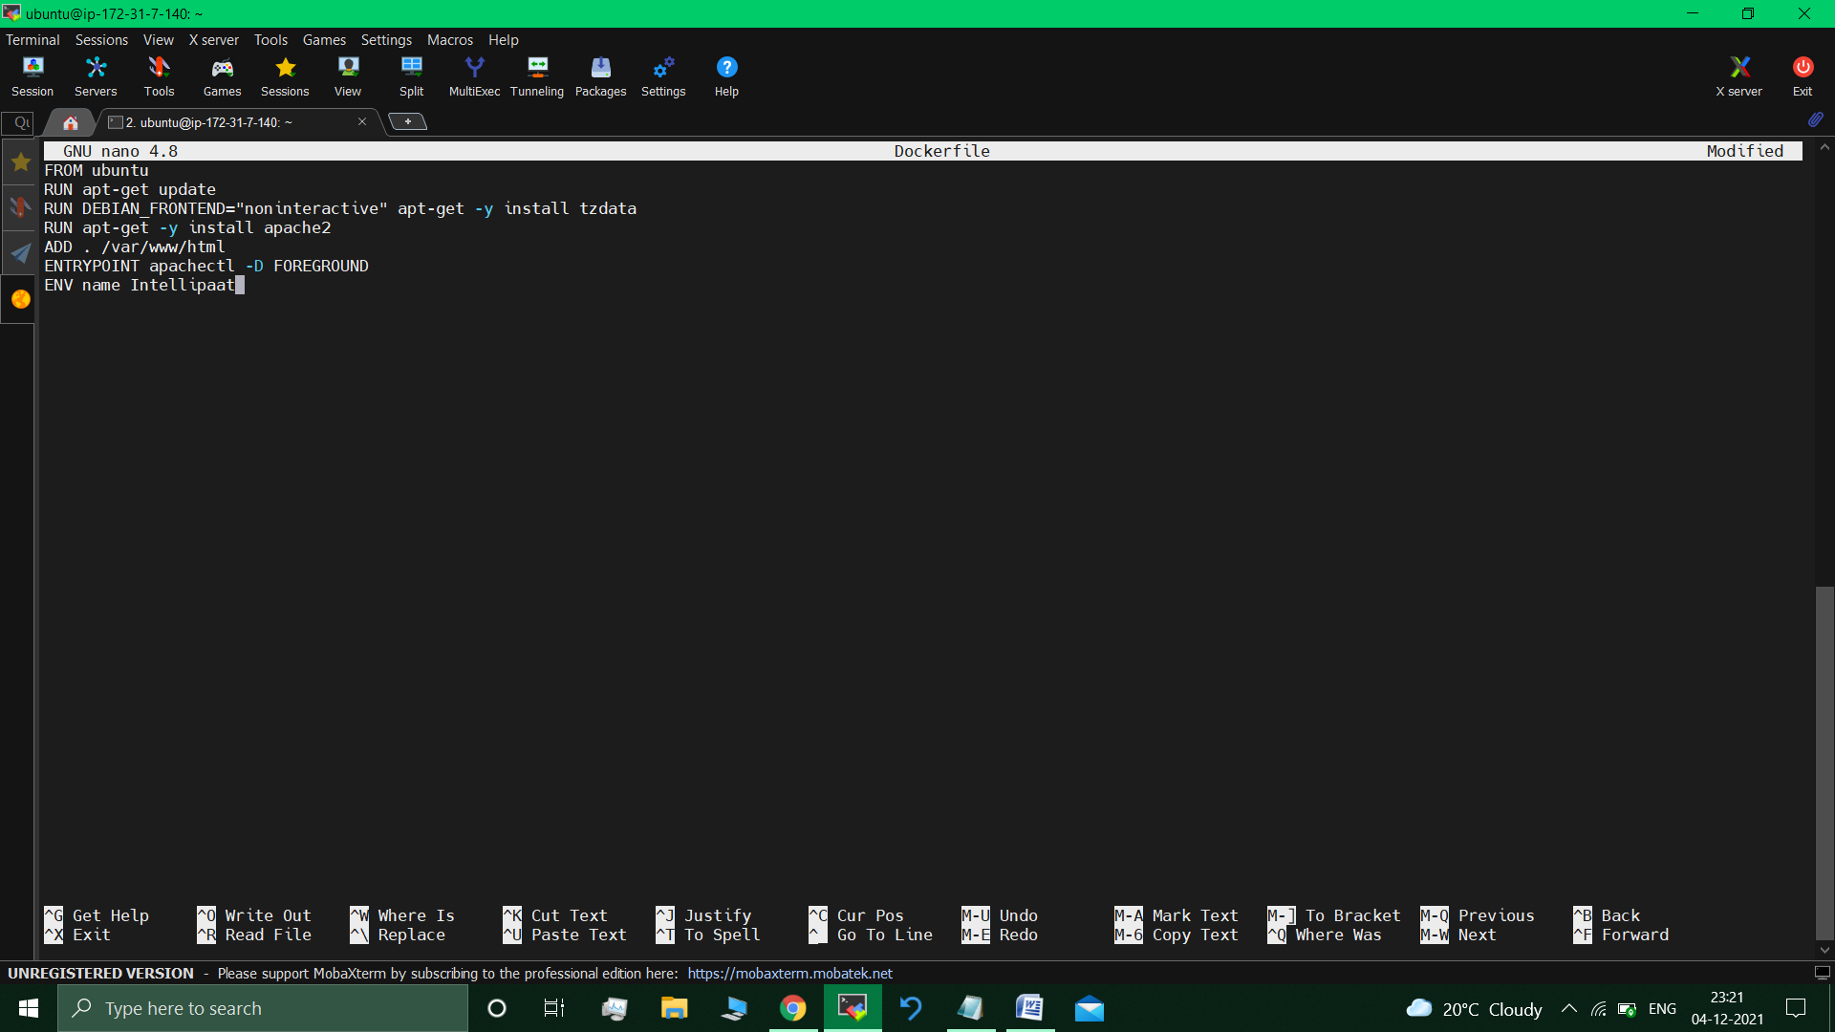

We need to have an image since it’ll contain the html file.

sudo nano index.html

sudo nano 1.html

**Building this Dockerfile :**

Sudo docker build . –t app1 //app1 – image tag/name

// Successfully built 2929e5d4f542

sudo docker images

// REPOSITORY TAG IMAGE ID CREATED SIZE

app1 latest 2929e5d4f542 53 seconds ago 220MB

sindevops/img_01 latest c1ff285bc668 2 days ago 218MB

ubuntu latest ba6acccedd29 7 weeks ago 72.8MB //

**$ sudo docker run -itd -p 85:80 *app1*** *//running* ***container*** *from the image*

40bcfc07a2d2059e20429ae98c354256d8af568eef59586410cba1782abbdba3

//Apache2 service started automatically.

**Visiting the Apache2 page**

**Google search the Public IP : 85 (85 – port)**

**: http://3.145.107.2:85**



So,Apache2 service automatically starts upon visiting the webpage. //Default web page was replaced.

**Dockerfile used :-**

***Apache2 Dockerfile :***

FROM ubuntu

RUN apt-get update

RUN DEBIAN_FRONTEND="noninteractive" apt-get -y install tzdata

RUN apt-get -y install apache2

ADD . /var/www/html

ENTRYPOINT apachectl -D FOREGROUND

ENV name Intellipaat

**Submitted By : Tushar Sinha**

**Email ID :** [**sinhatushar17@gmail.com**](mailto:sinhatushar17@gmail.com)

**Enrolled in the “DevOps Architect Master’s Training Program”**